Administration Site Screen Shots

Date Issued: 20/07/2009

Table of Contents
1 Administration Site Screenshots 4

Table of Figures
Figure 1 – Login Page 4
Figure 2 – Change Password Page 5
Figure 3 – Manage Departments (Manager Home Page) 6
Figure 4 – Editing Department (READ) 7
Figure 5 – Update Department Page (UPDATE) 8
Figure 6 – Insert New Department (CREATE) 9
Figure 7 – View Categories in Department (Manage Department) 10
Figure 8 – Edit Category 11
Figure 9 – View Products in Category (Manage Category) 12
Figure 10 – Edit Category 13
Figure 11 – Manage Product Images 14
Figure 12 – Add Single Image to Product 15
Figure 13 – Add Multiple Images to Product 16
Figure 14 – Manage Category Image (Shown on BrowseDepartment page) 17
Figure 15 – Edit Category Image 18
Figure 16 – Manage Product Colors 19
Figure 17 – Edit Product Colors 20
Figure 18 – Manage Product Sizes 21
Figure 19 – Edit Product Sizes 22
Figure 20 – Manage Currencies 1 23
Figure 21 – Manage Currencies 2 24
Figure 22 – Edit Currencies 25
Figure 23 – Manage Suppliers 26
Figure 24 – Edit Suppliers 27
Figure 25 – Manage Emails 28
Figure 26 – Reply to Emails from Customers 29
Figure 27 – Sample Reply to Customer Email (for use by employees) 30
Figure 28 – Unacceptable Email Attempted Send 31
Figure 29 – Successfully Sent Email 32
Figure 30 – Manage Unacceptable Words 33
Figure 31 – Manage Users 34
Figure 32 – Edit Users 35
Figure 33 – Manage Orders 1 36
Figure 34 – Manage Orders 2 37
Figure 35 – Order Details 38
Figure 36 – Customer Details 39
Figure 37 – Admin Home Page 40
Figure 38 – Staff Home Page 41

Administration Site Screenshots
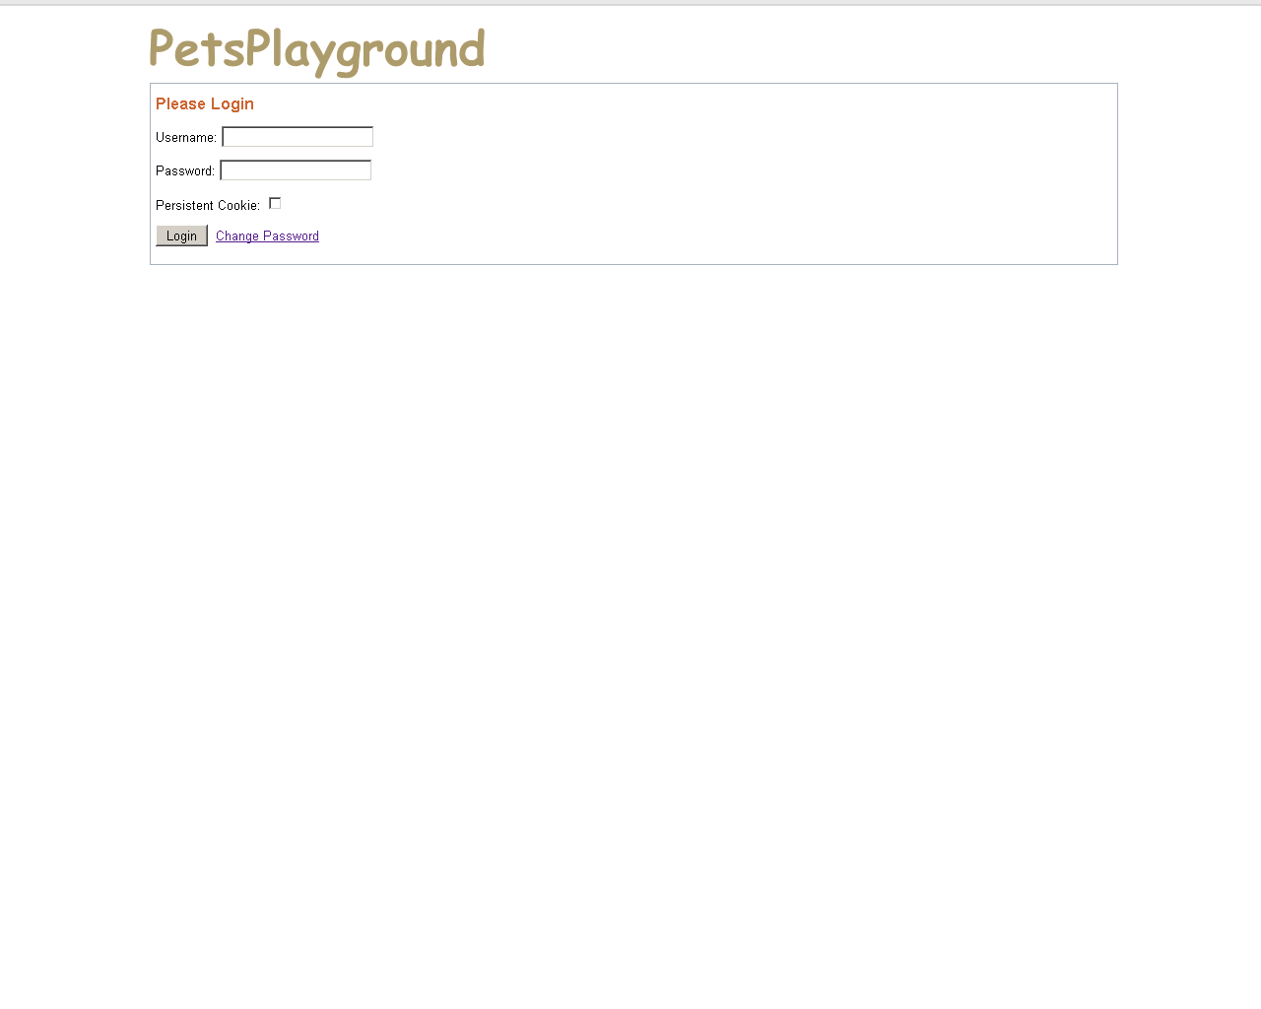
Figure 1 – Login Page
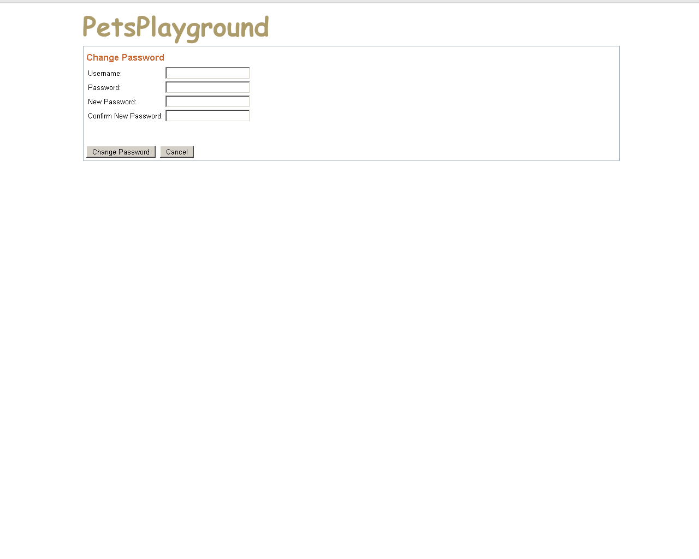
Figure 2 – Change Password Page
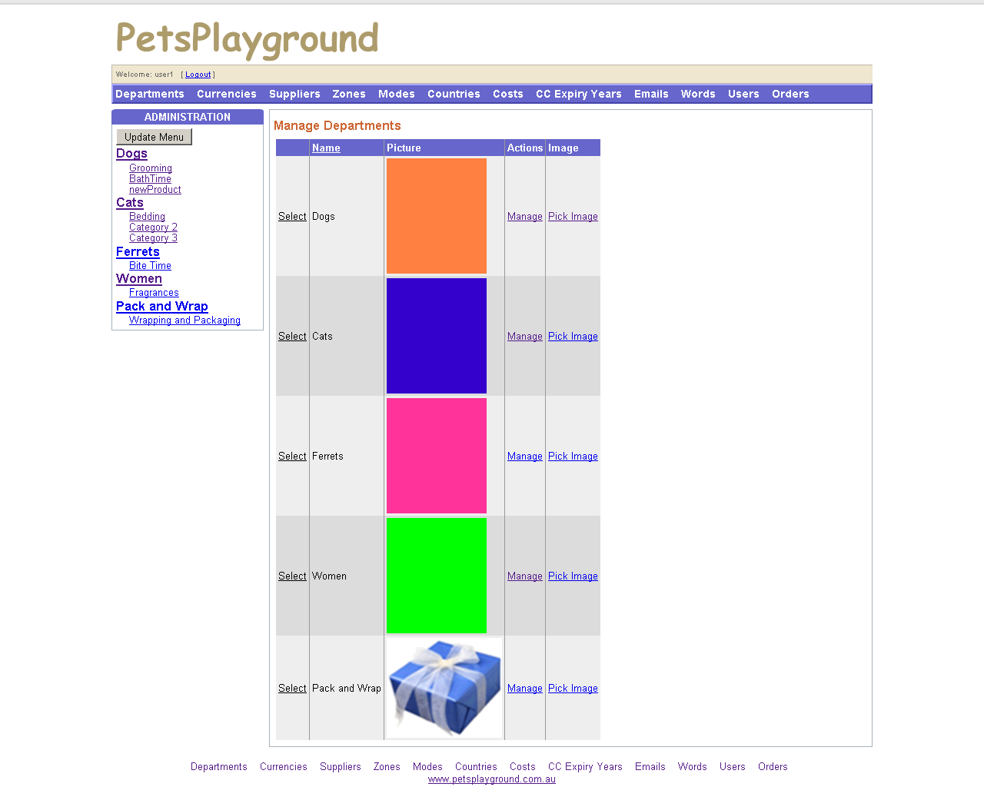
Figure 3 – Manage Departments (Manager Home Page)
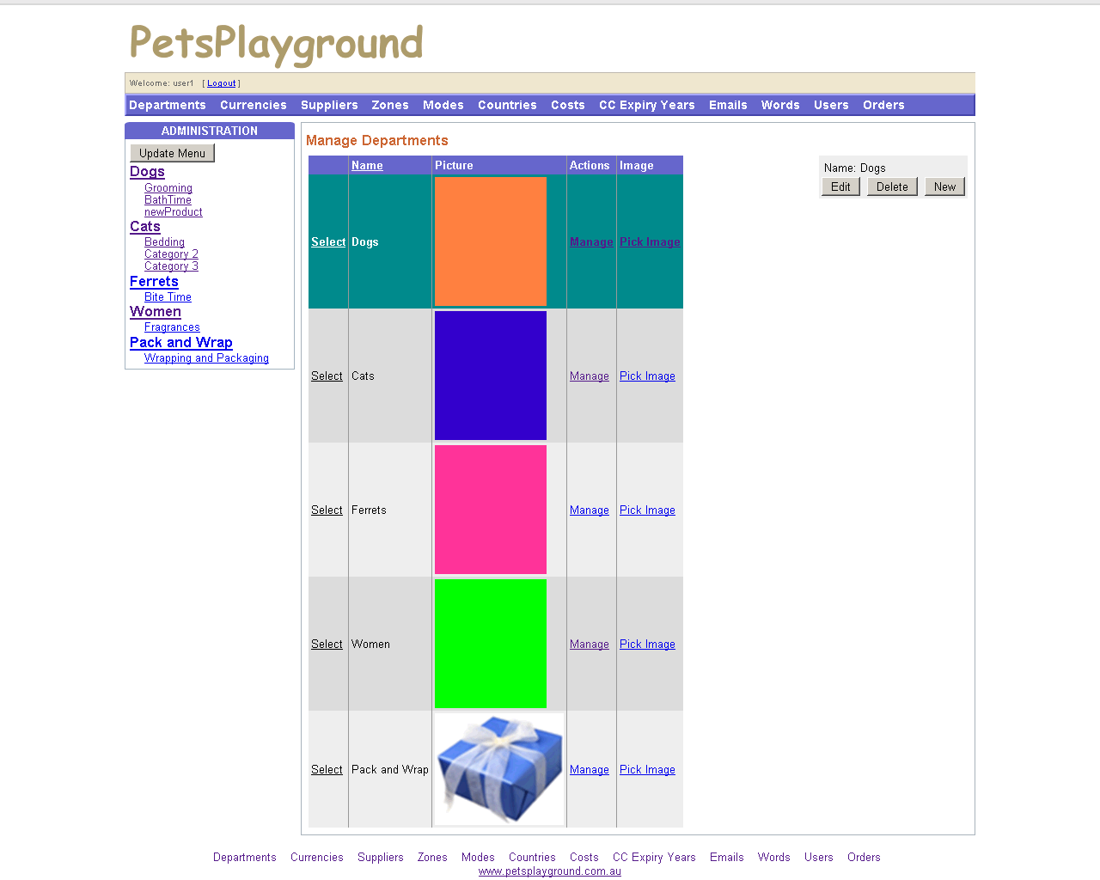
Figure 4 – Editing Department (READ)
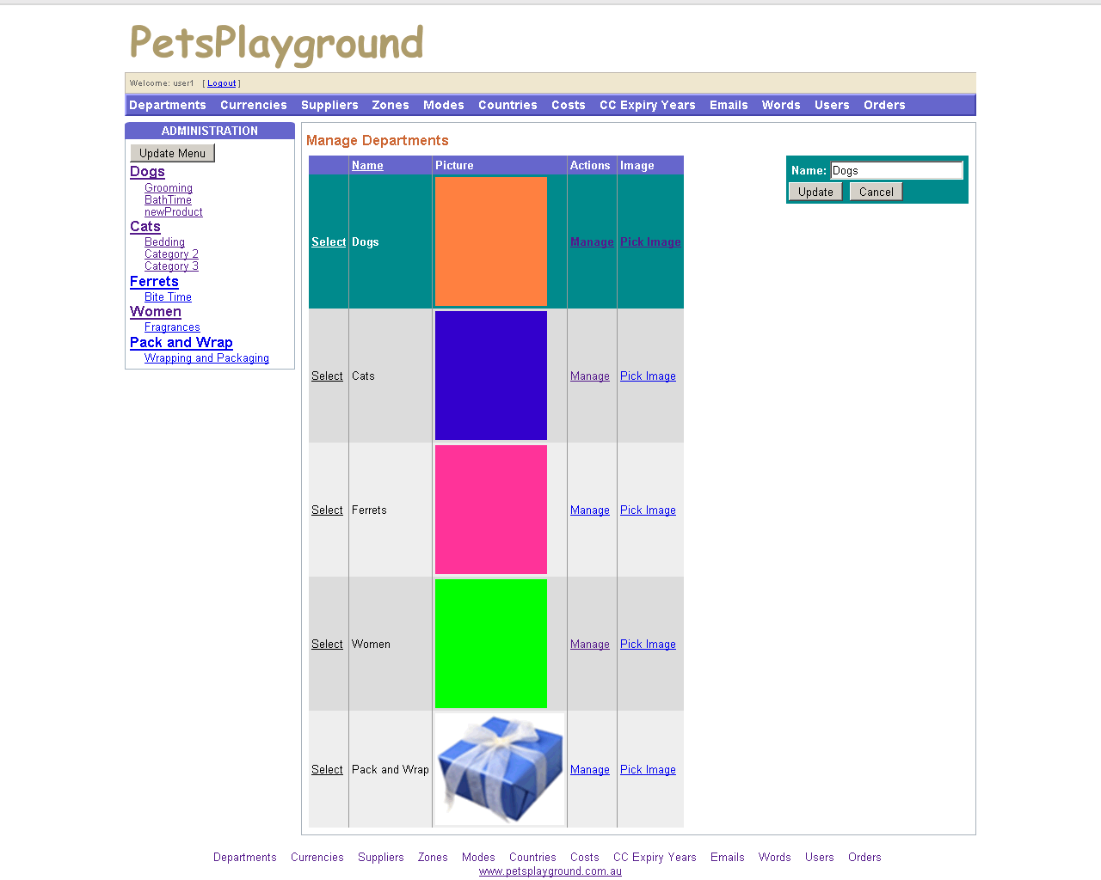
Figure 5 – Update Department Page (UPDATE)
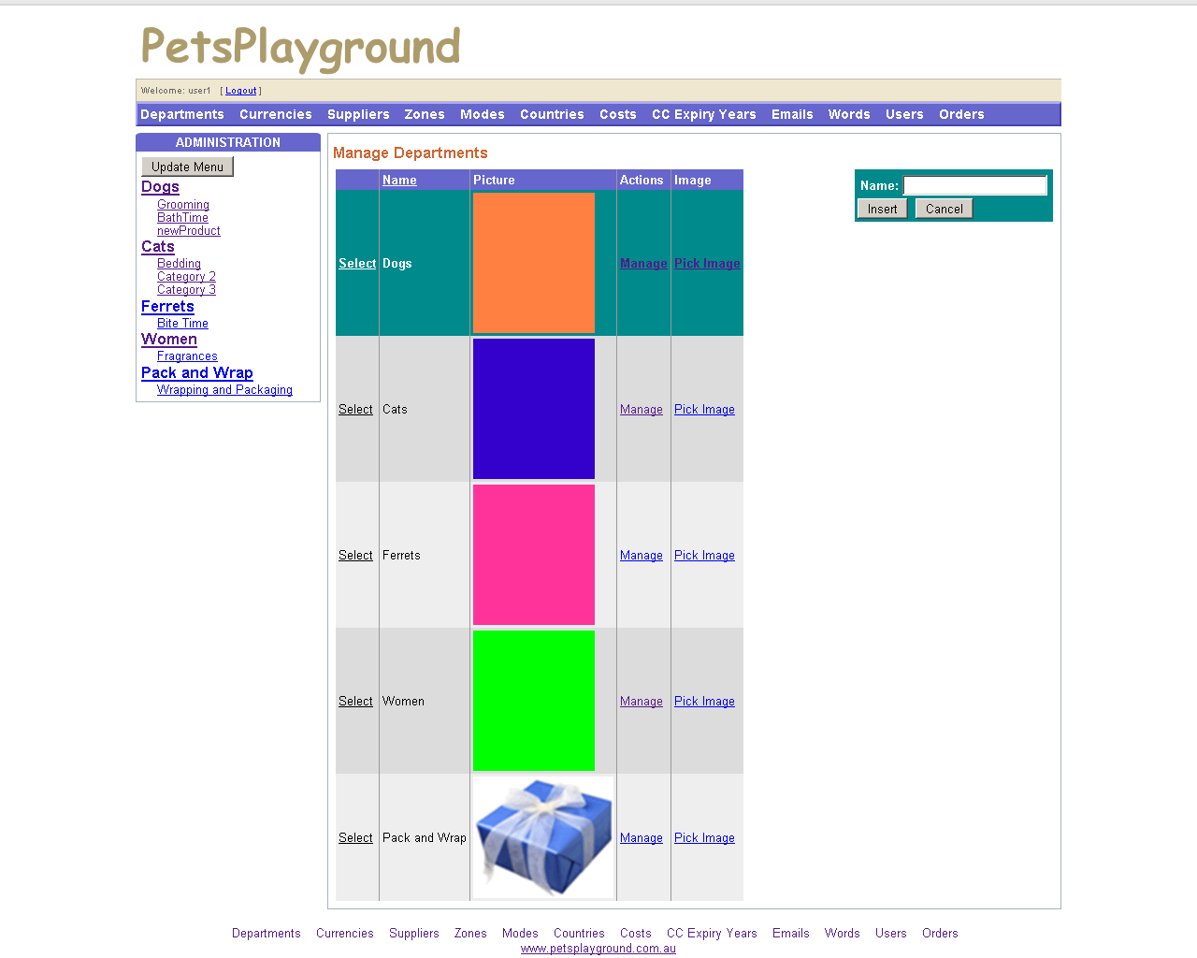
Figure 6 – Insert New Department (CREATE)
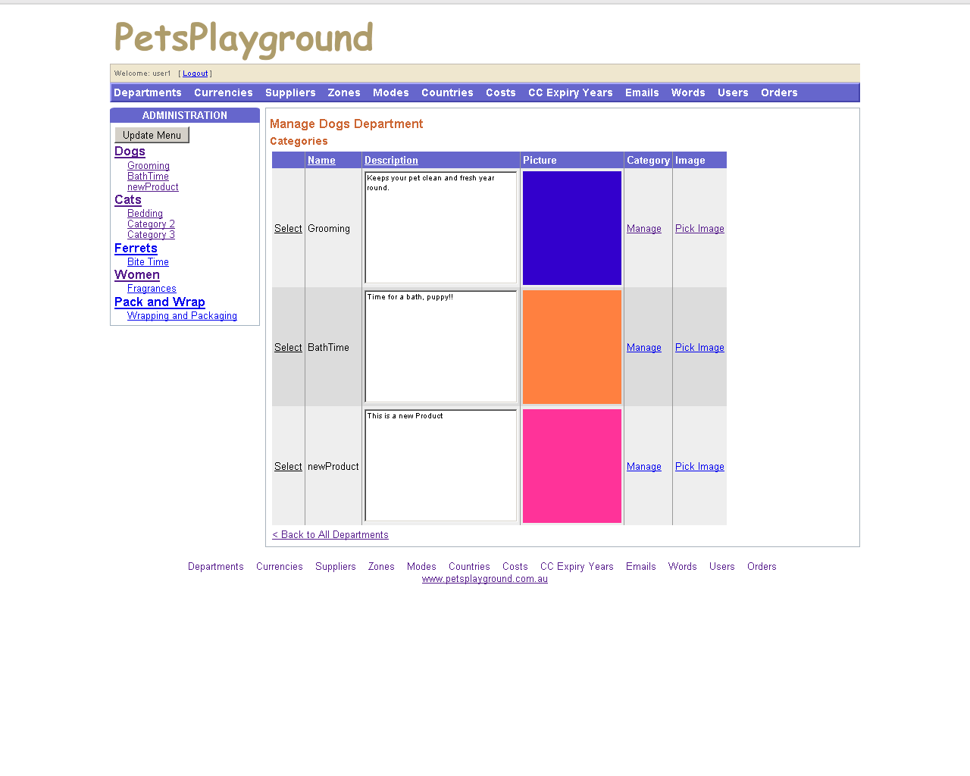
Figure 7 – View Categories in Department (Manage Department)
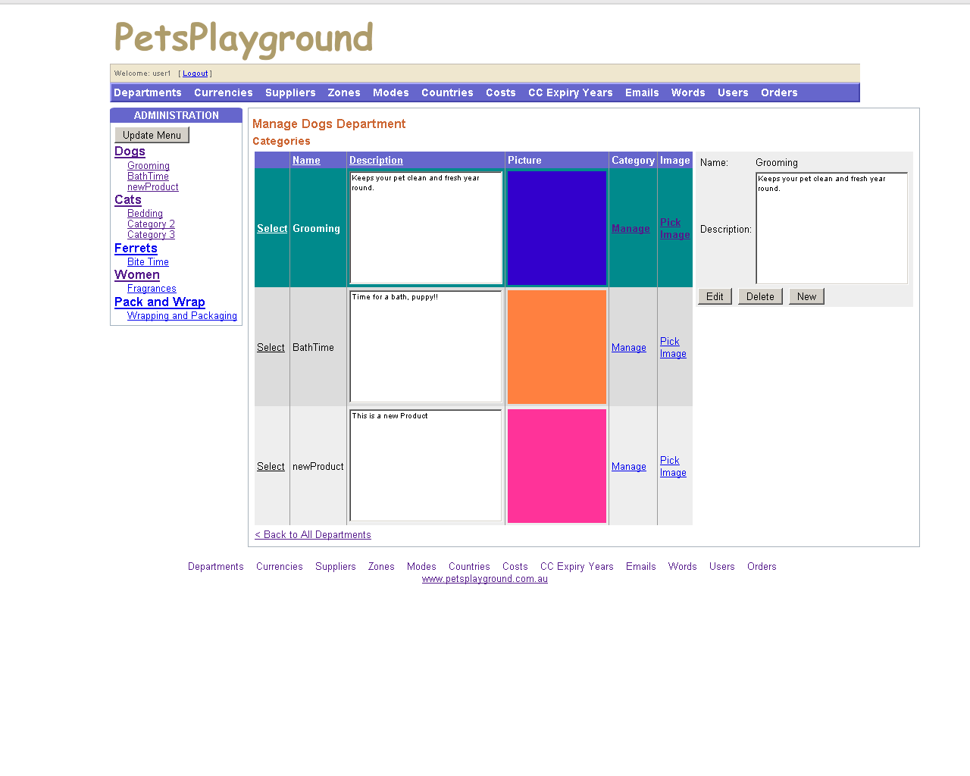
Figure 8 – Edit Category
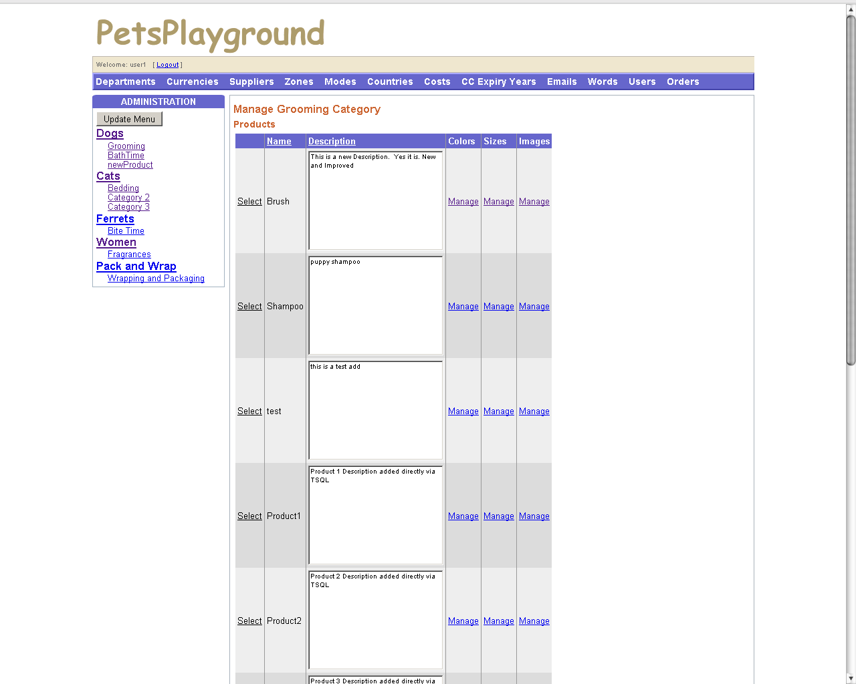
Figure 9 – View Products in Category (Manage Category)
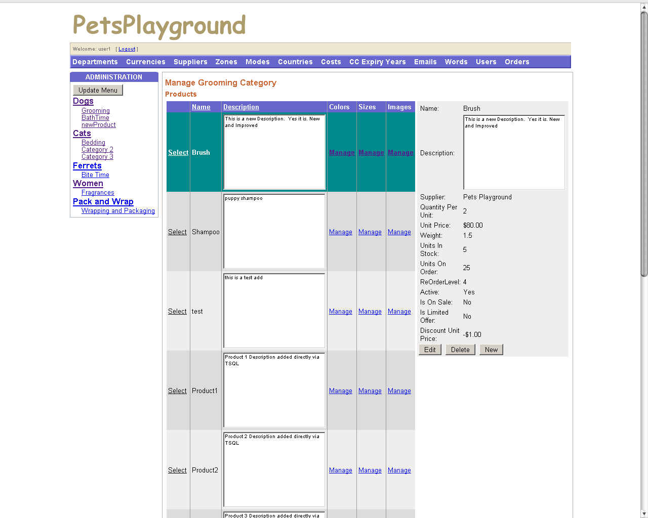
Figure 10 – Edit Category
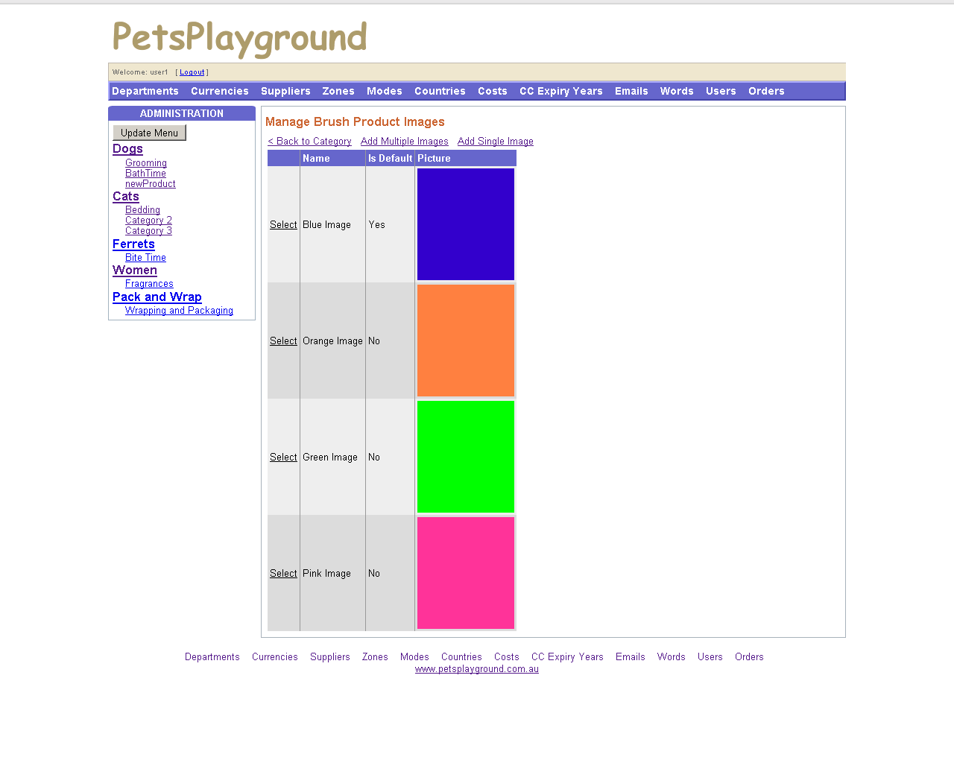
Figure 11 – Manage Product Images
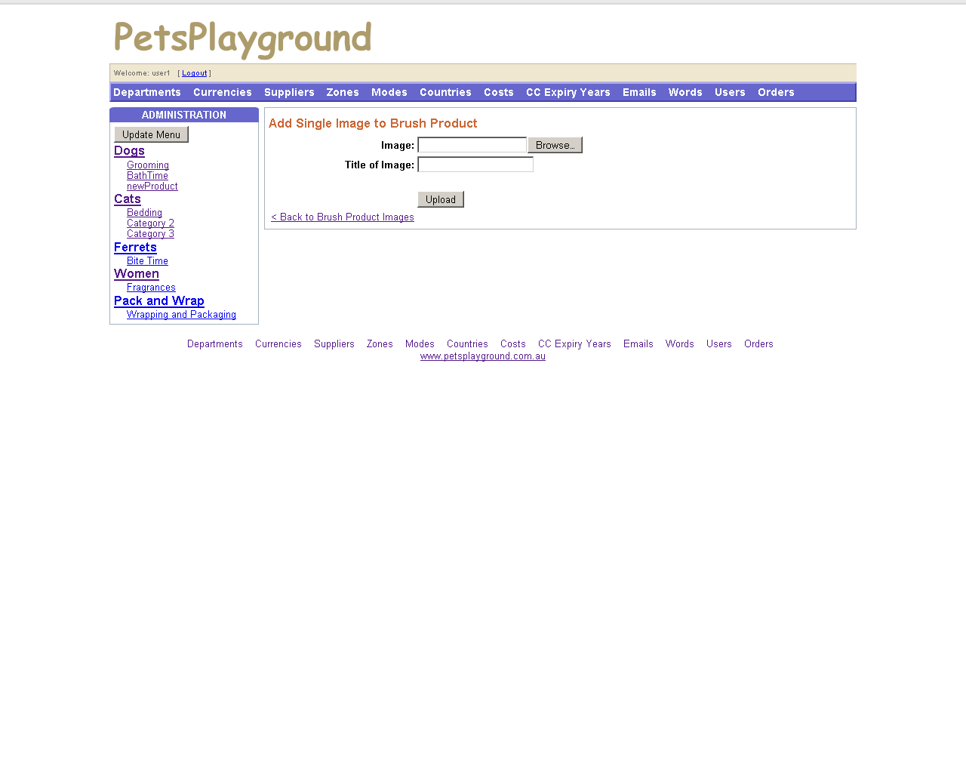
Figure 12 – Add Single Image to Product
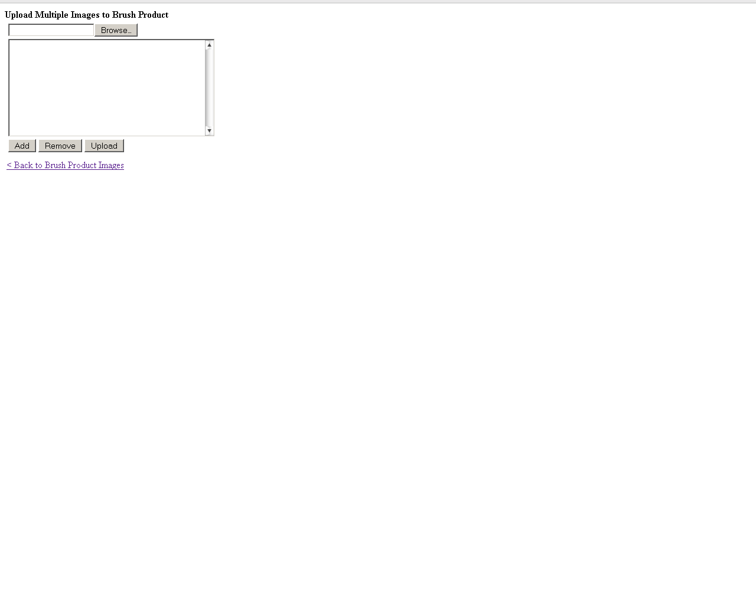
Figure 13 – Add Multiple Images to Product
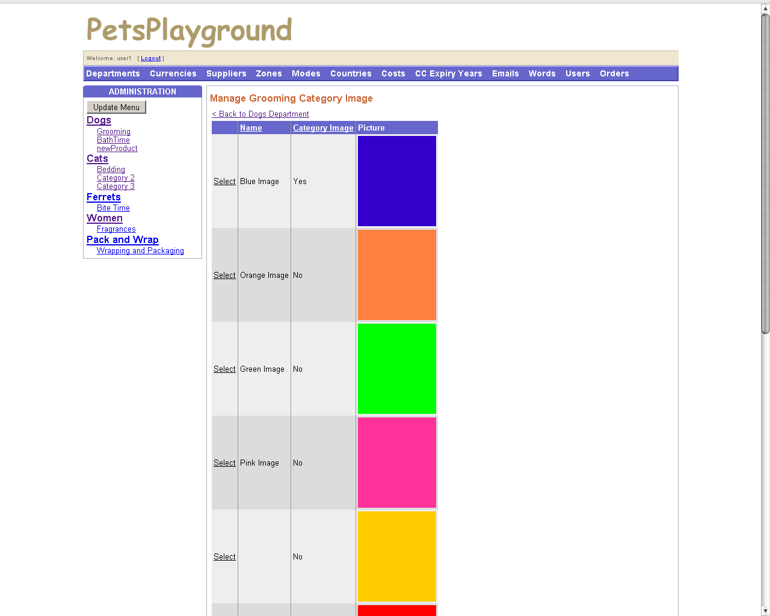
Figure 14 – Manage Category Image (Shown on BrowseDepartment page)
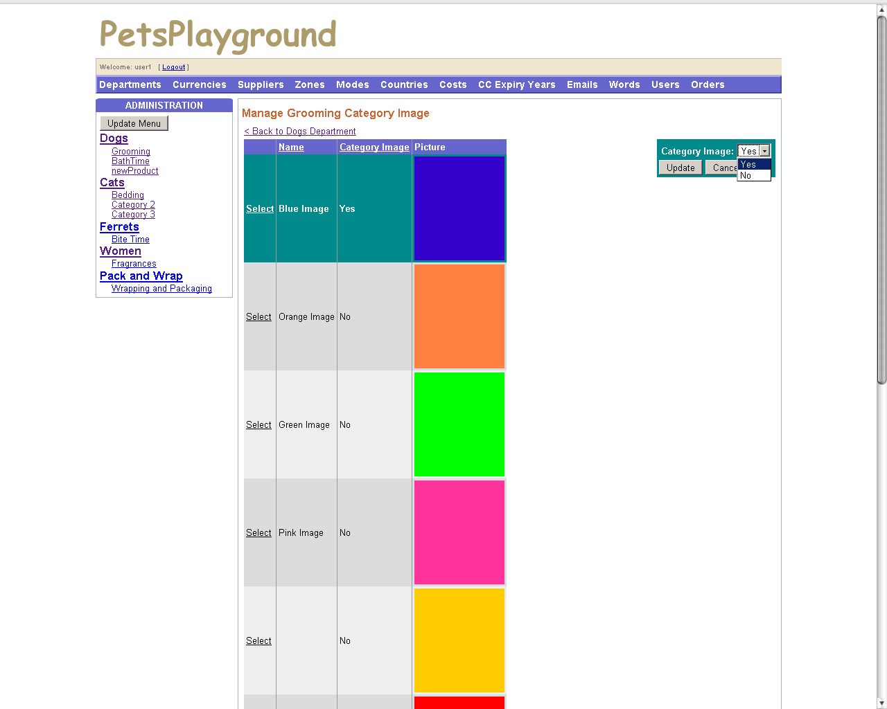
Figure 15 – Edit Category Image
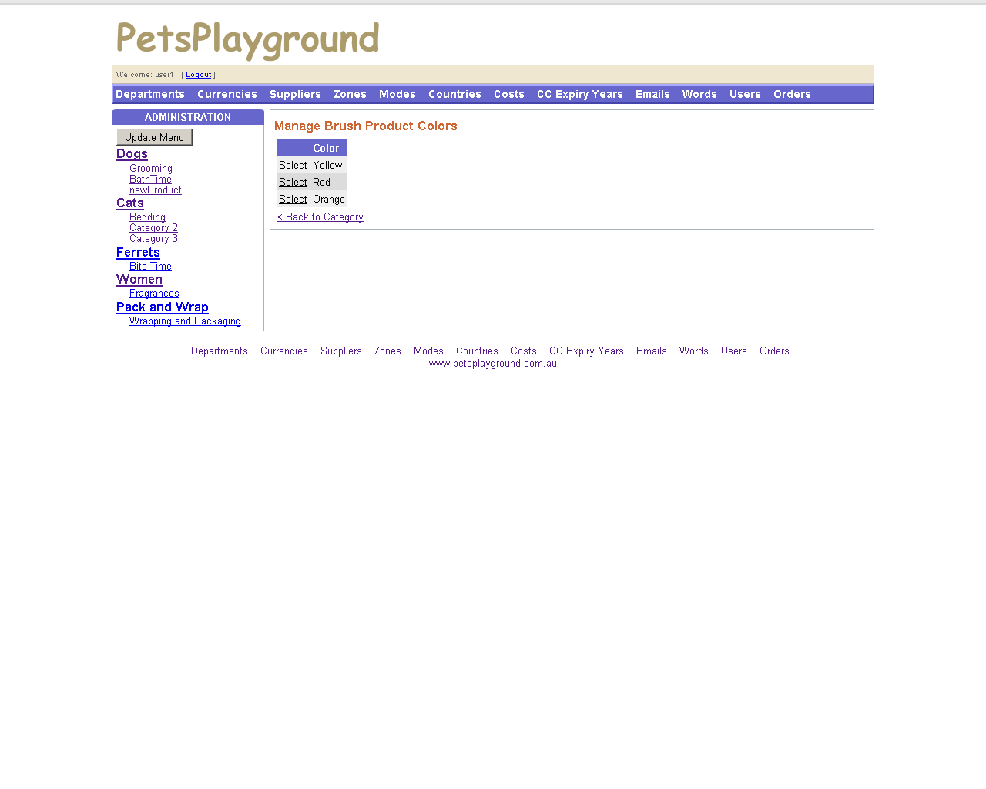
Figure 16 – Manage Product Colors
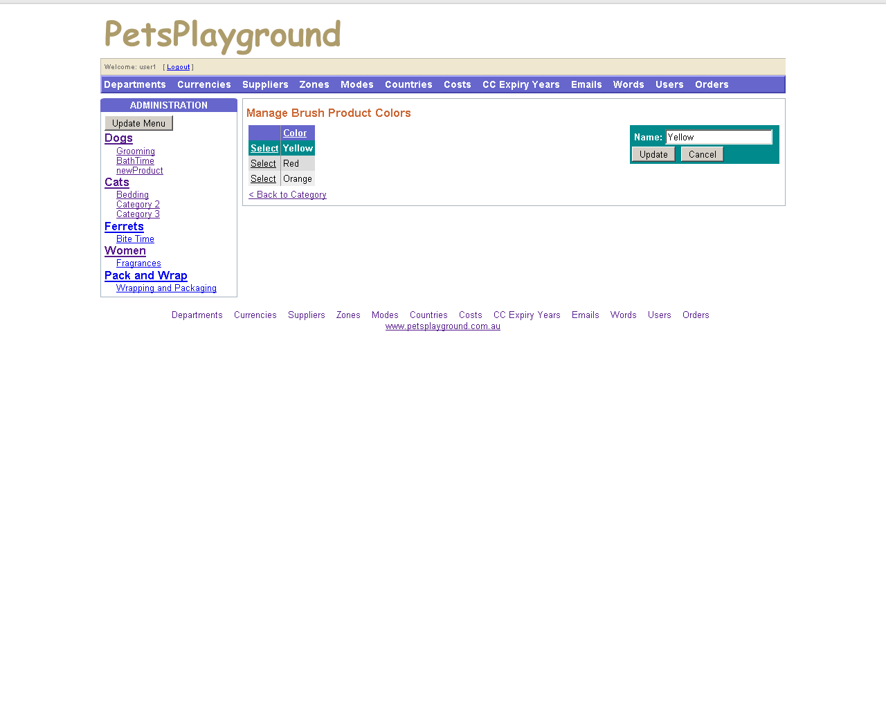
Figure 17 – Edit Product Colors
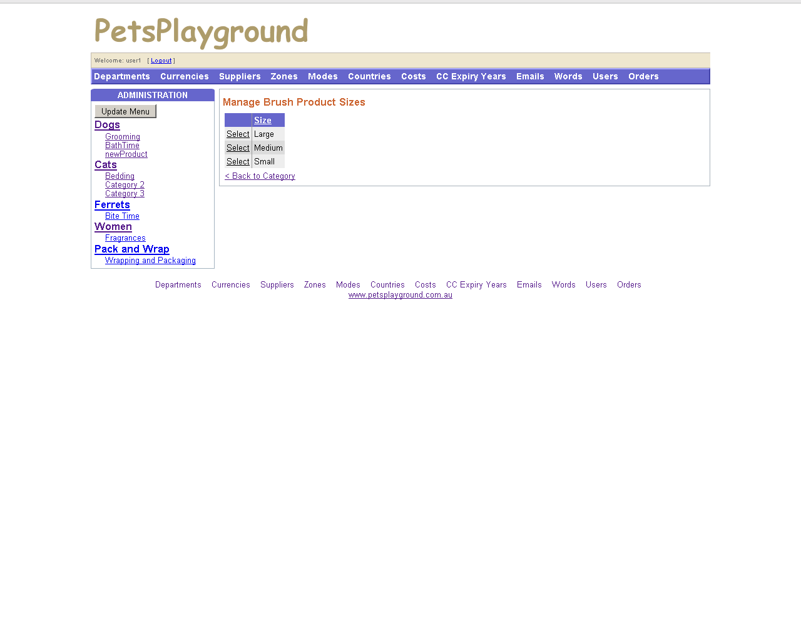
Figure 18 – Manage Product Sizes
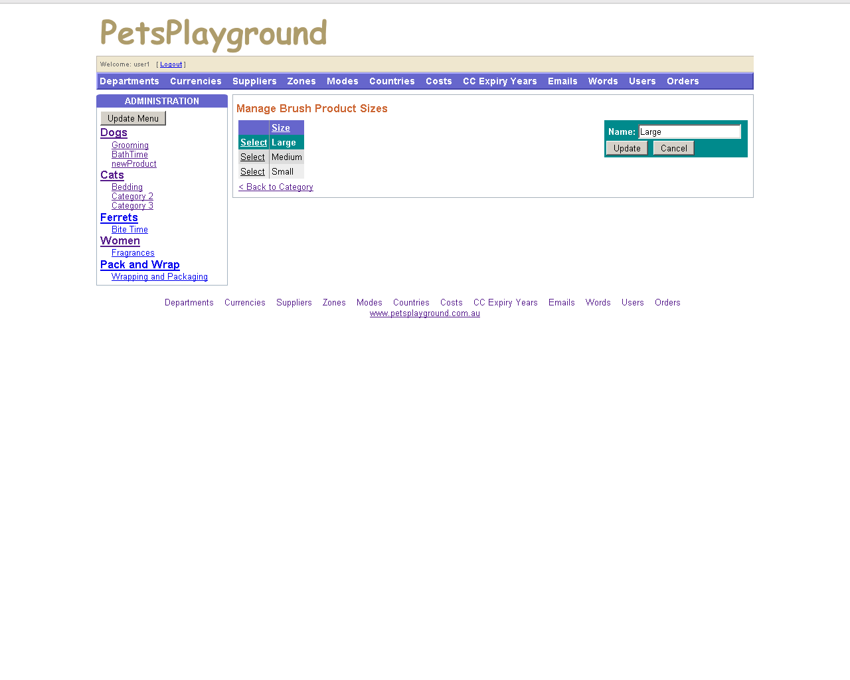
Figure 19 – Edit Product Sizes
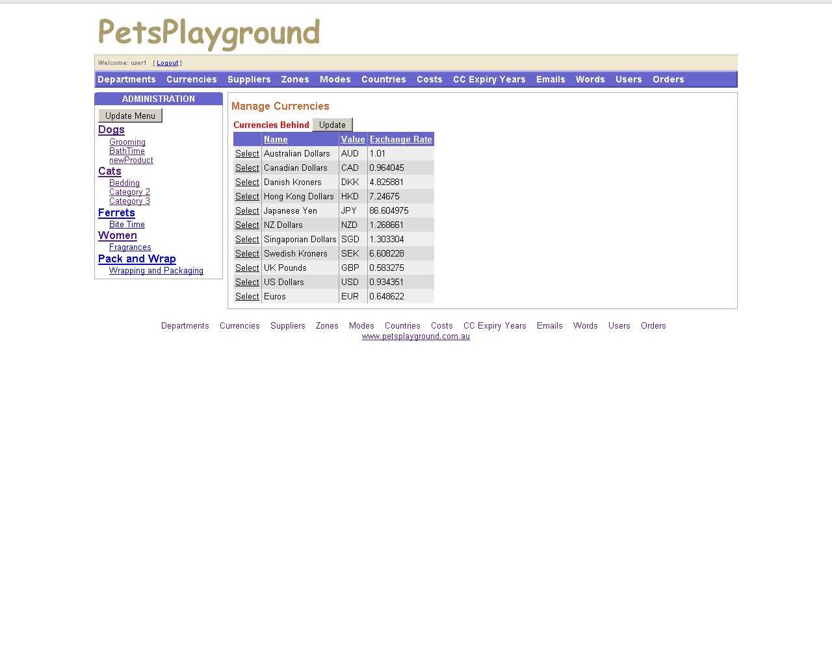
Figure 20 – Manage Currencies 1
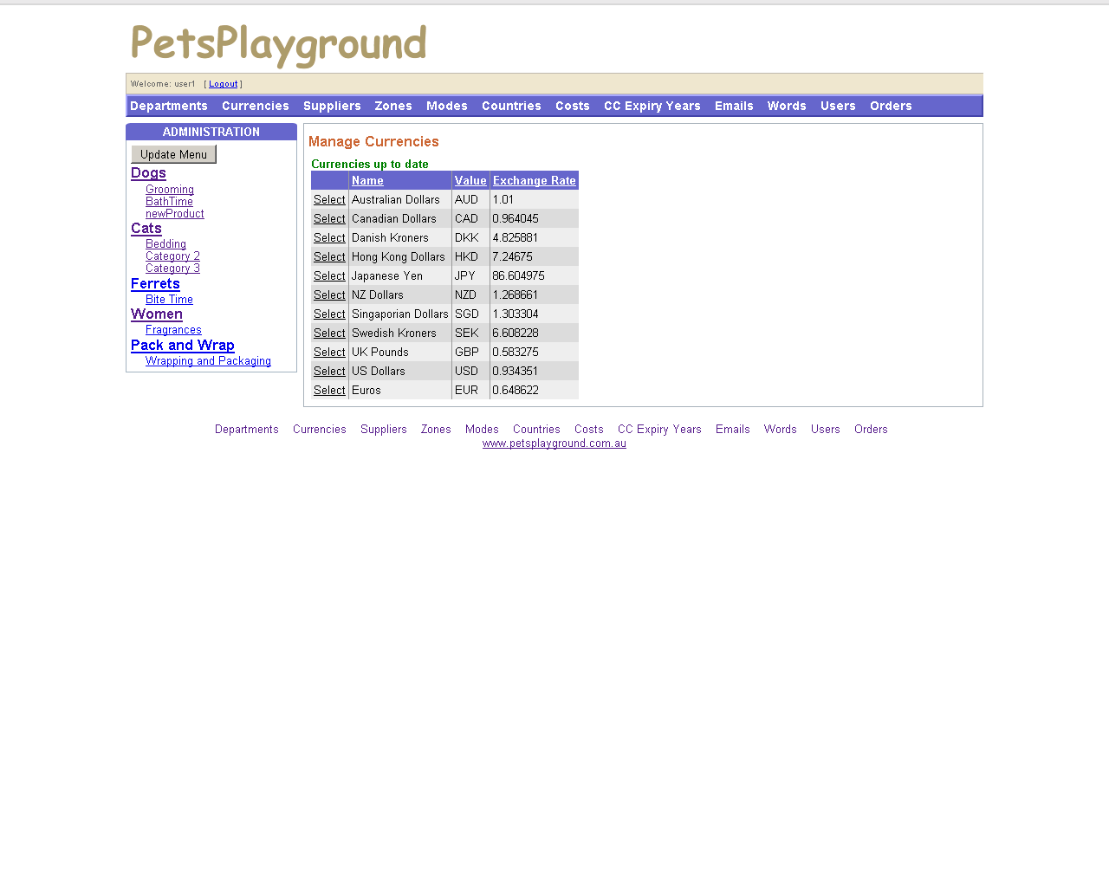
Figure 21 – Manage Currencies 2
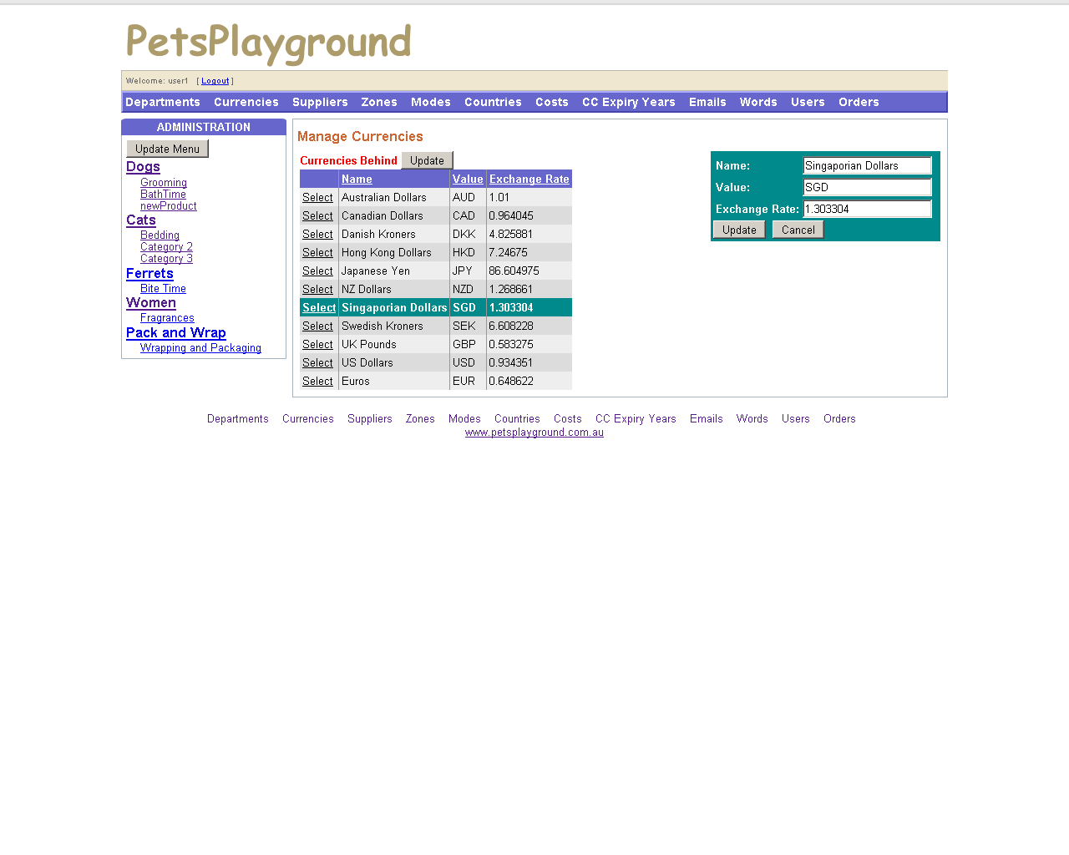
Figure 22 – Edit Currencies
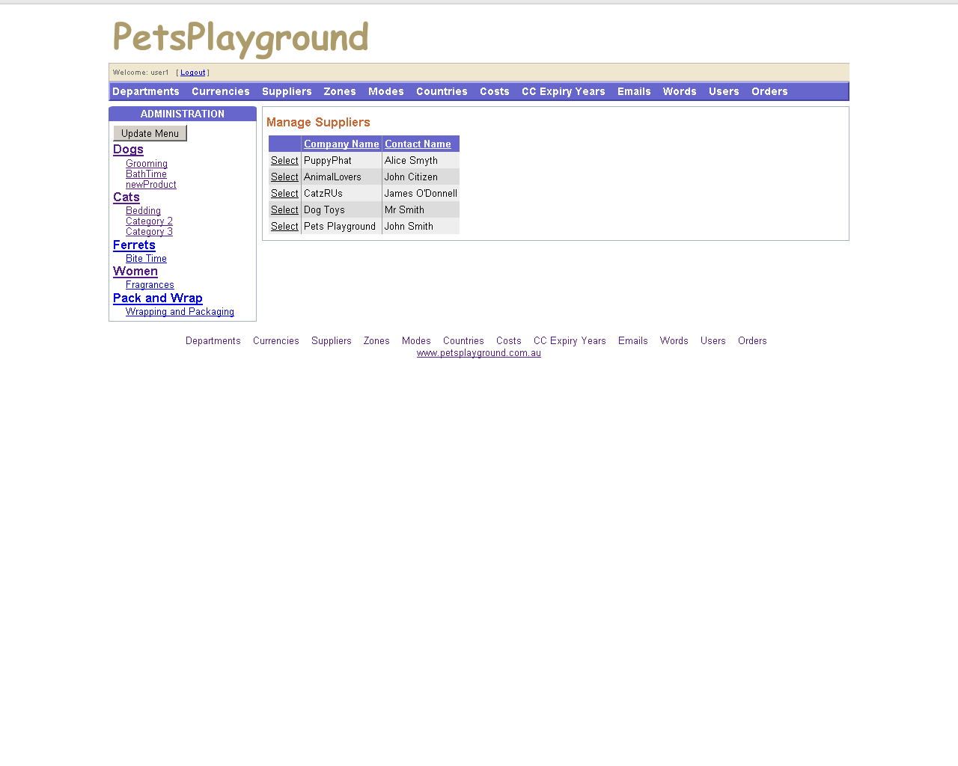
Figure 23 – Manage Suppliers
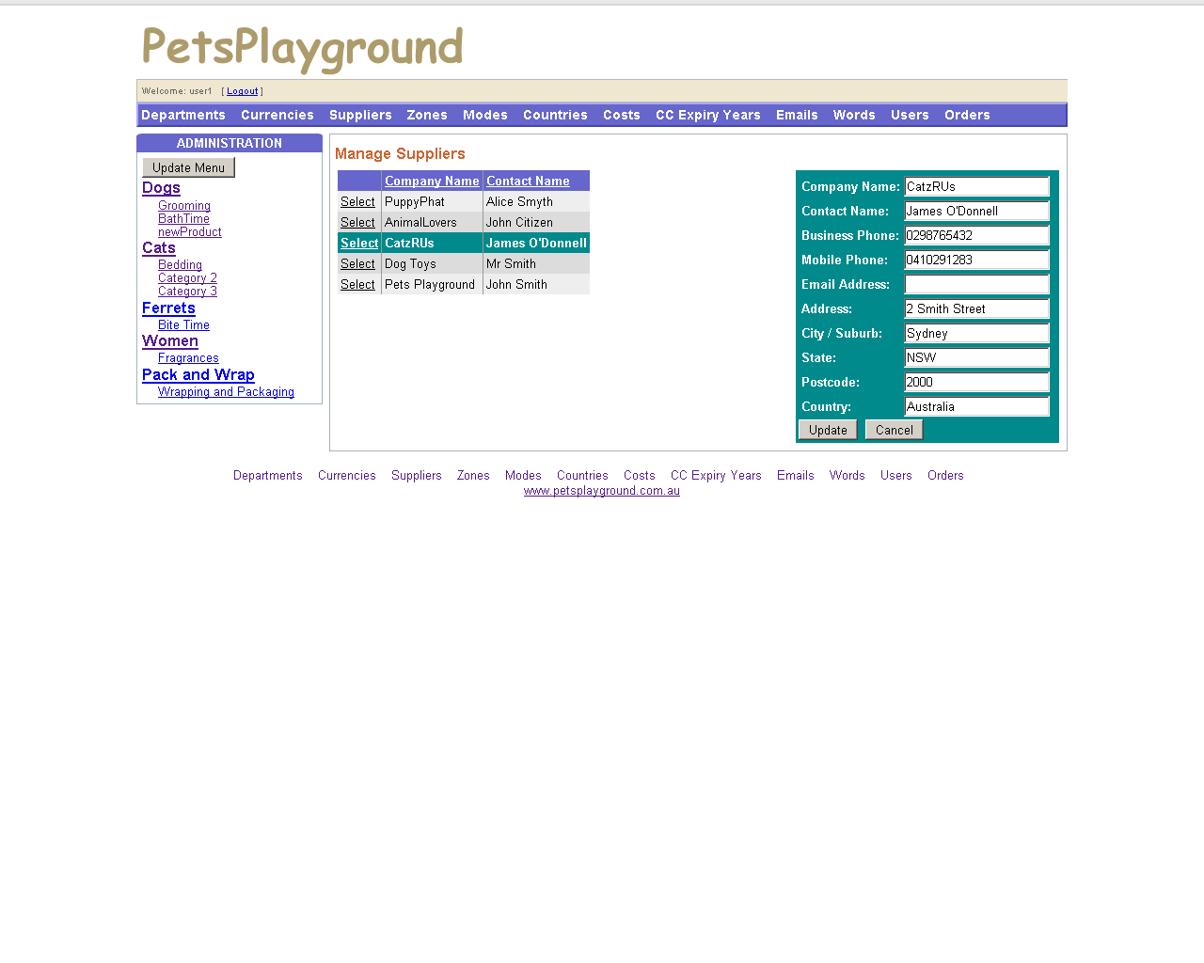
Figure 24 – Edit Suppliers
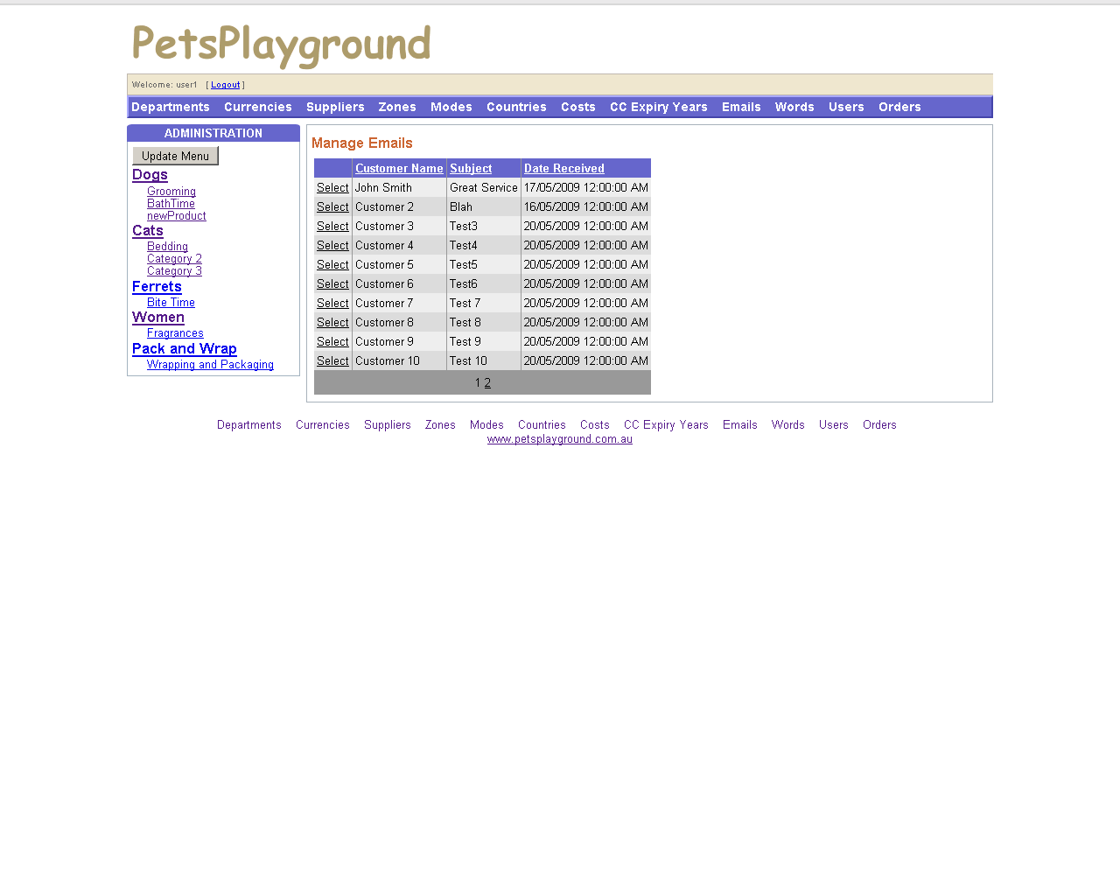
Figure 25 – Manage Emails
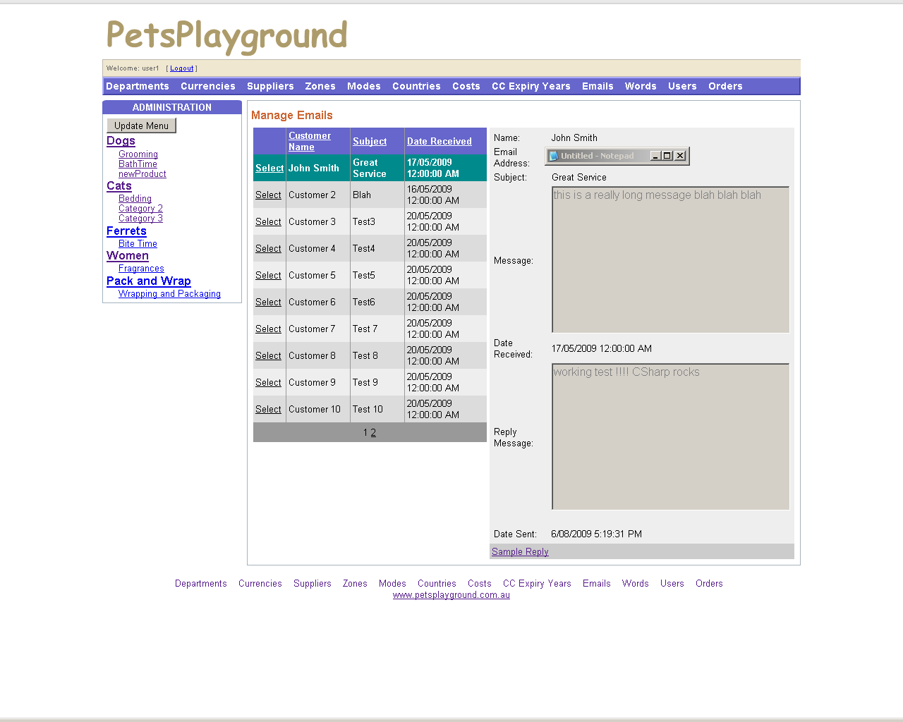
Figure 26 – Reply to Emails from Customers

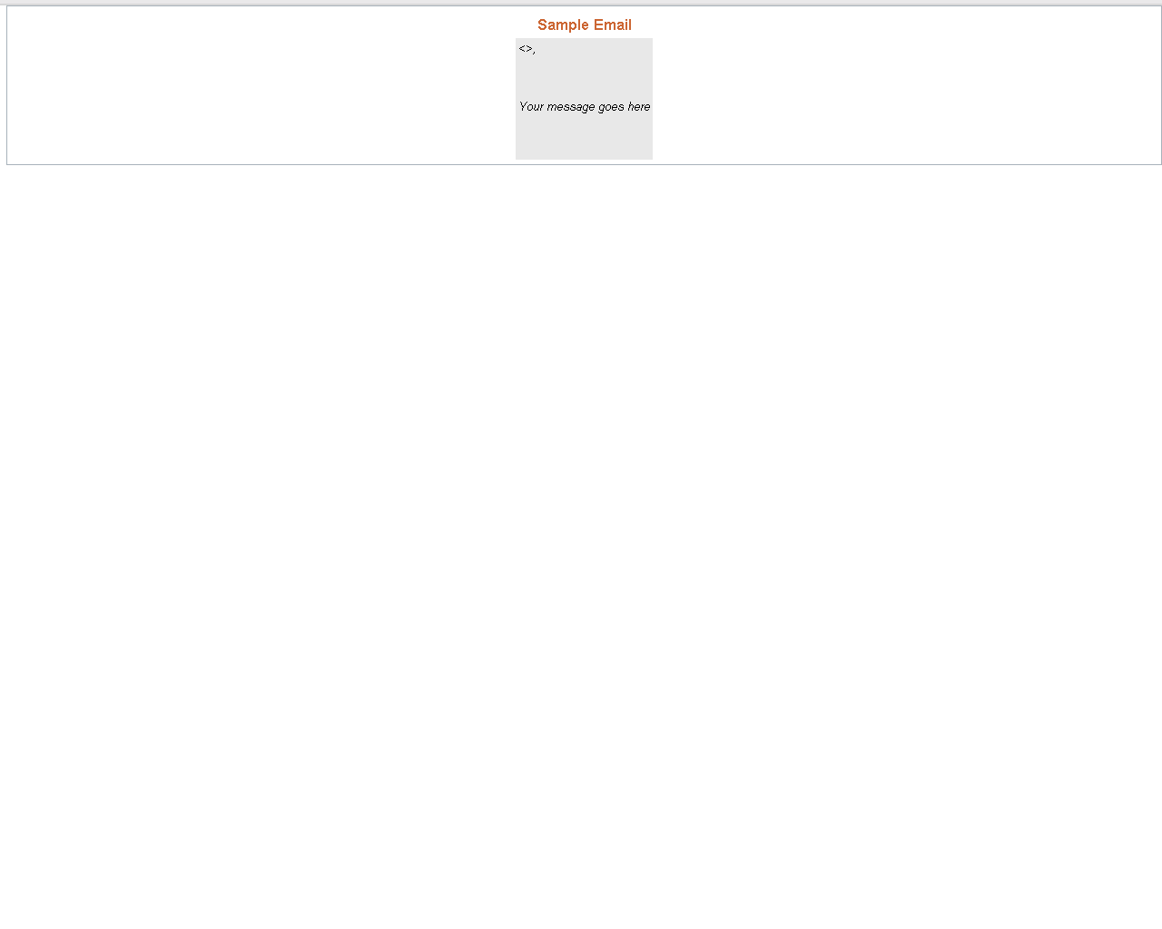
Figure 27 – Sample Reply to Customer Email (for use by employees)
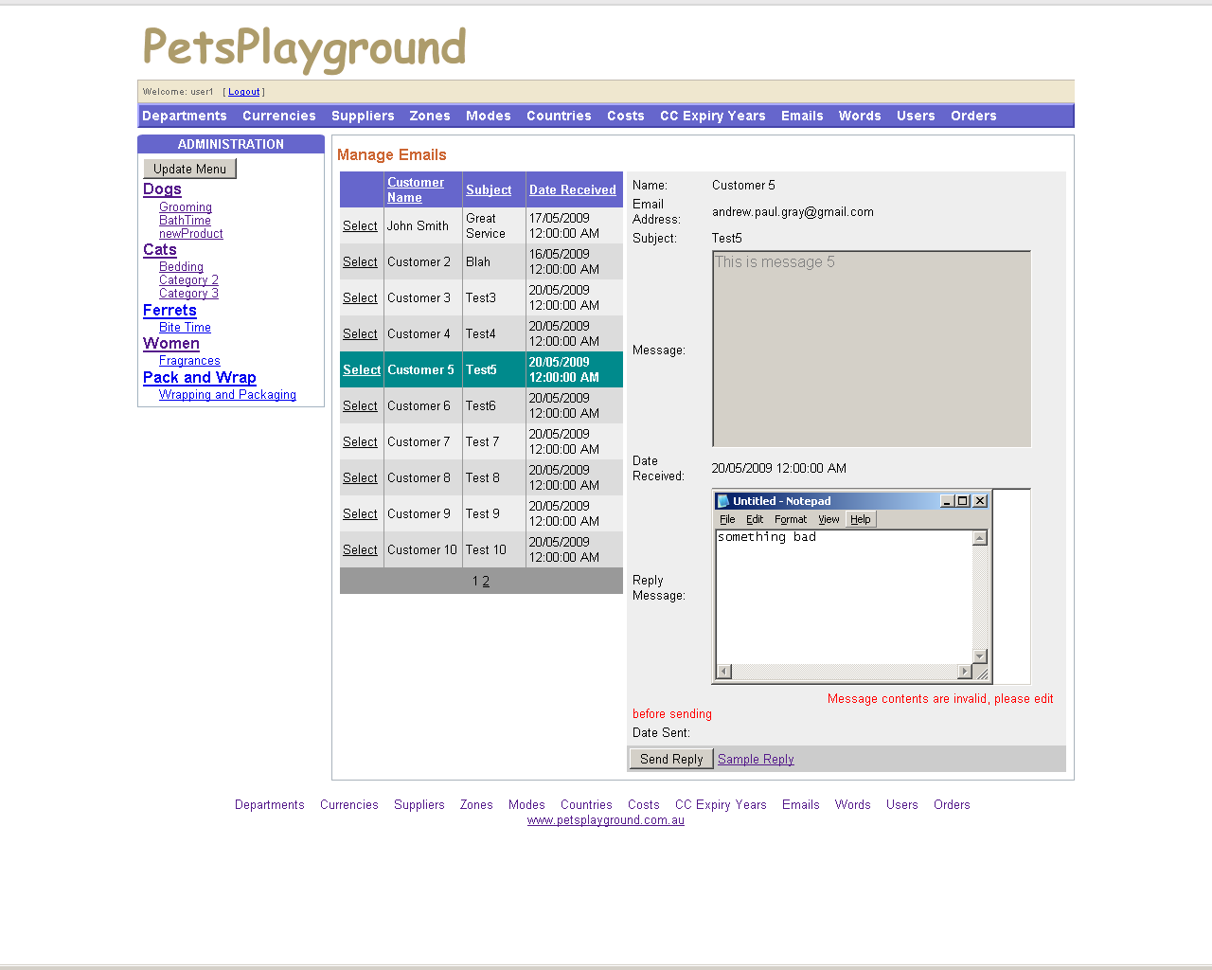
Figure 28 – Unacceptable Email Attempted Send
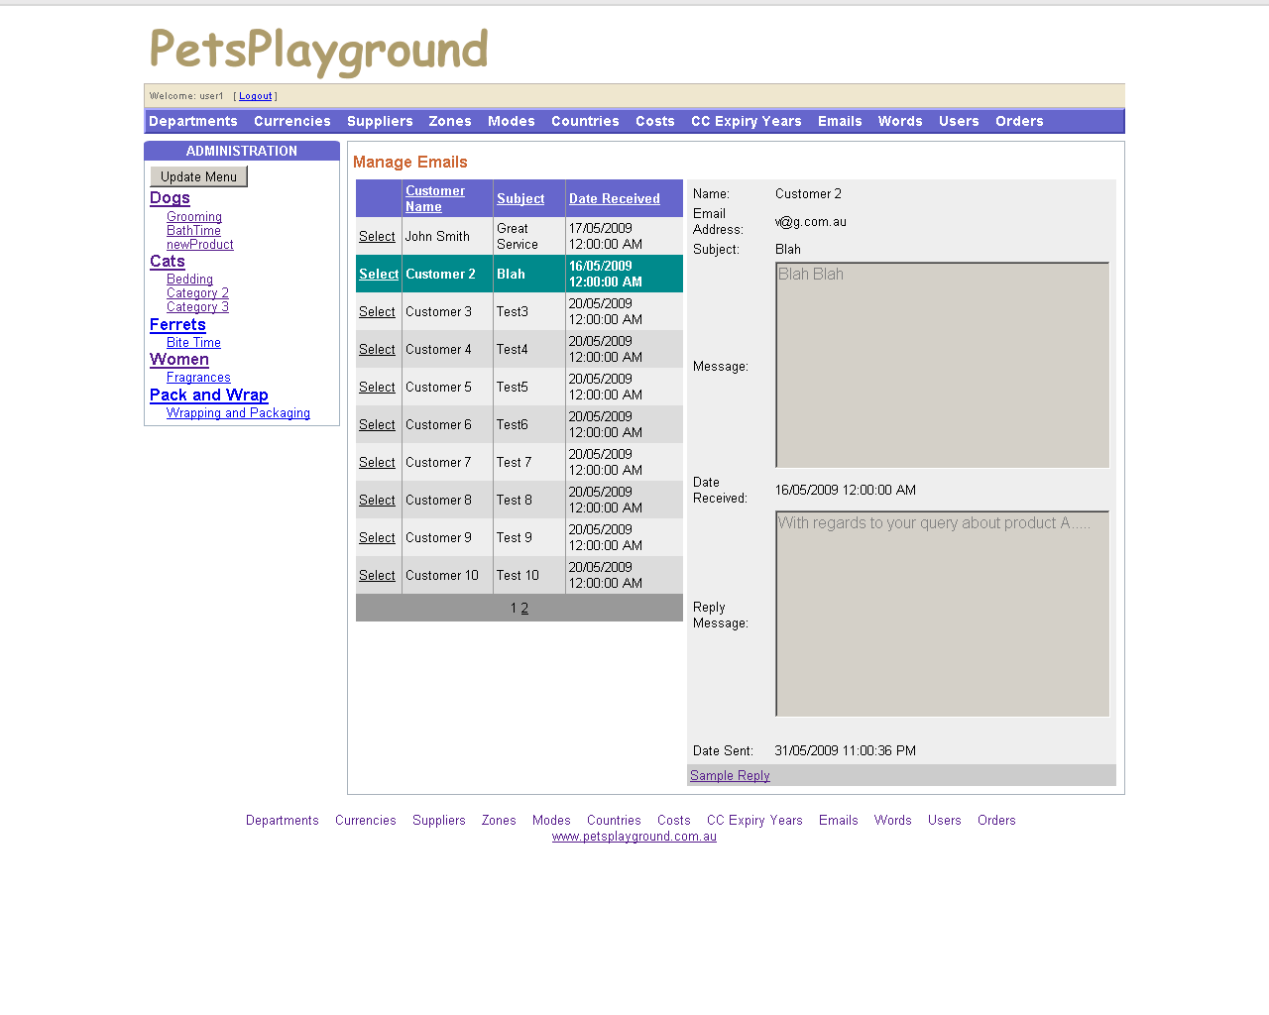
Figure 29 – Successfully Sent Email
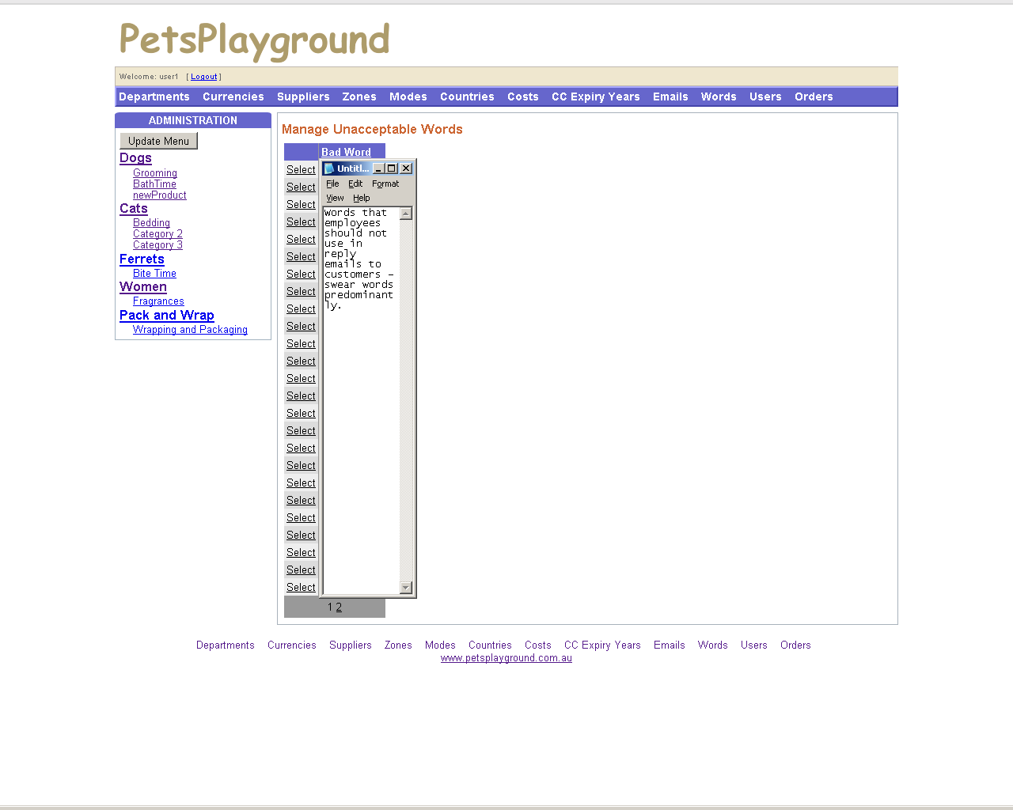
Figure 30 – Manage Unacceptable Words
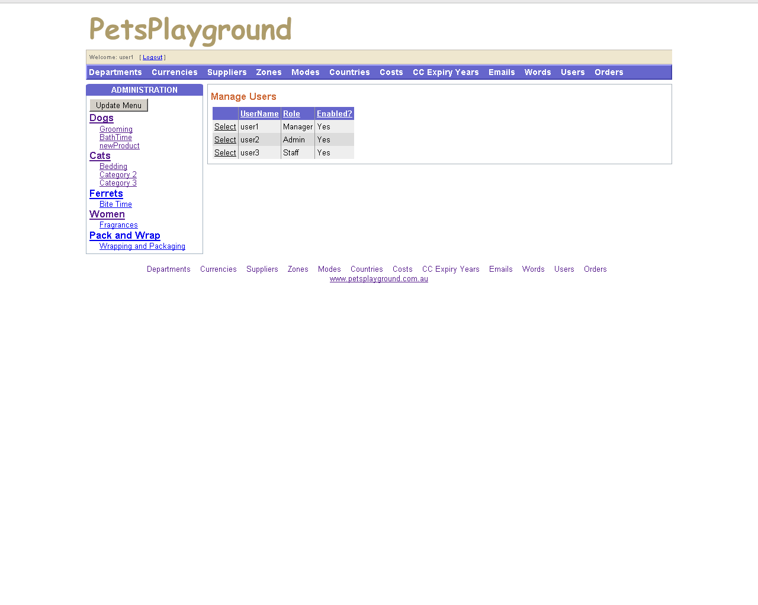
Figure 31 – Manage Users
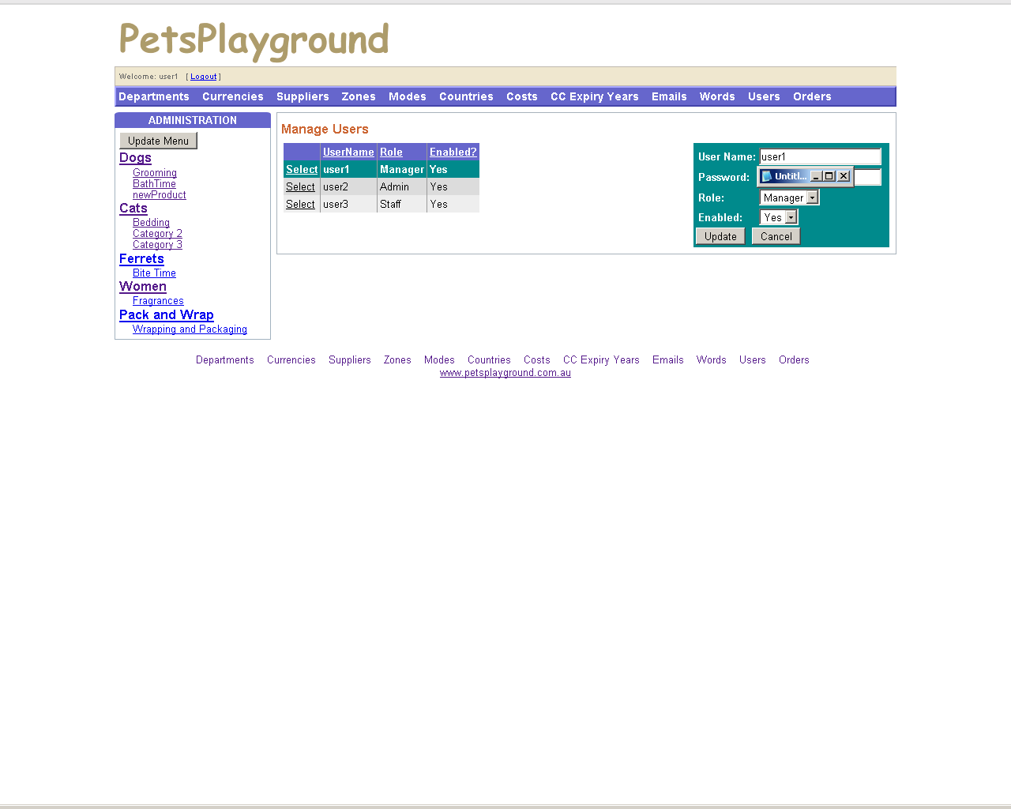
Figure 32 – Edit Users
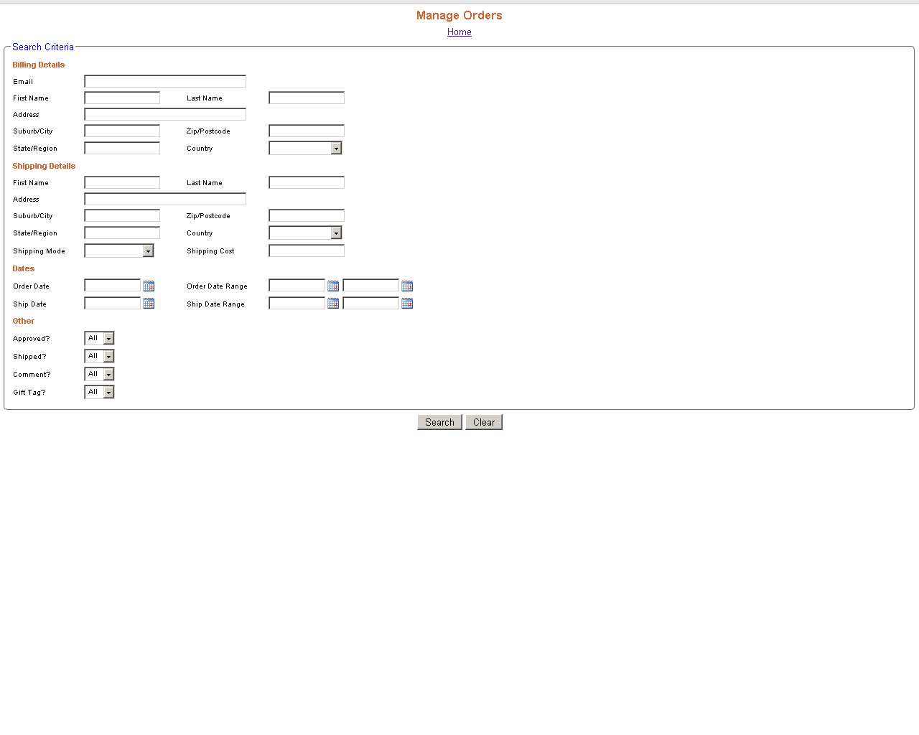
Figure 33 – Manage Orders 1
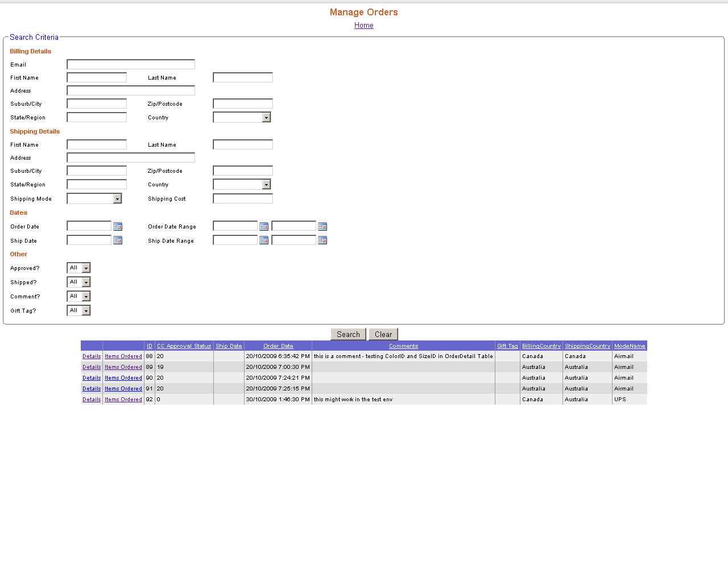
Figure 34 – Manage Orders 2
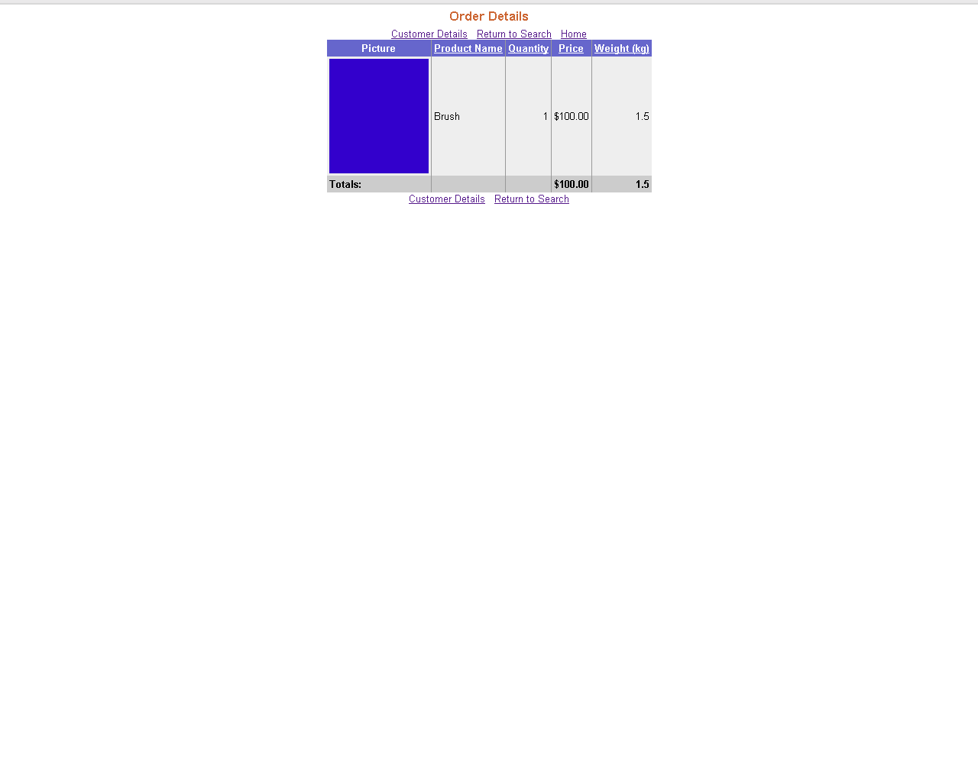
Figure 35 – Order Details
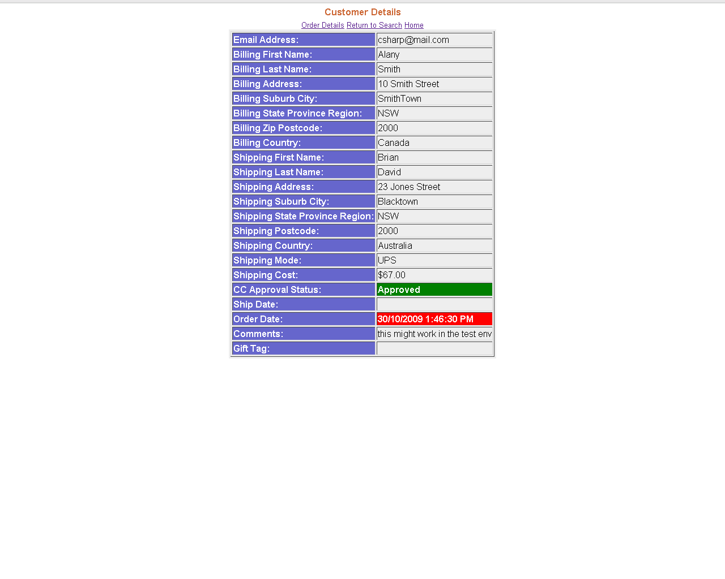
Figure 36 – Customer Details
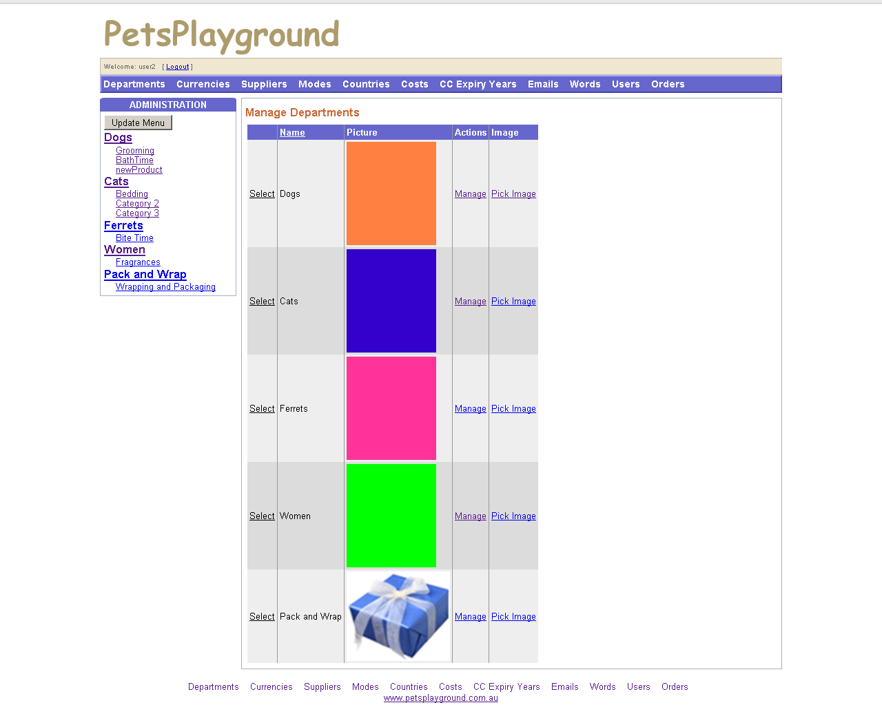
Figure 37 – Admin Home Page
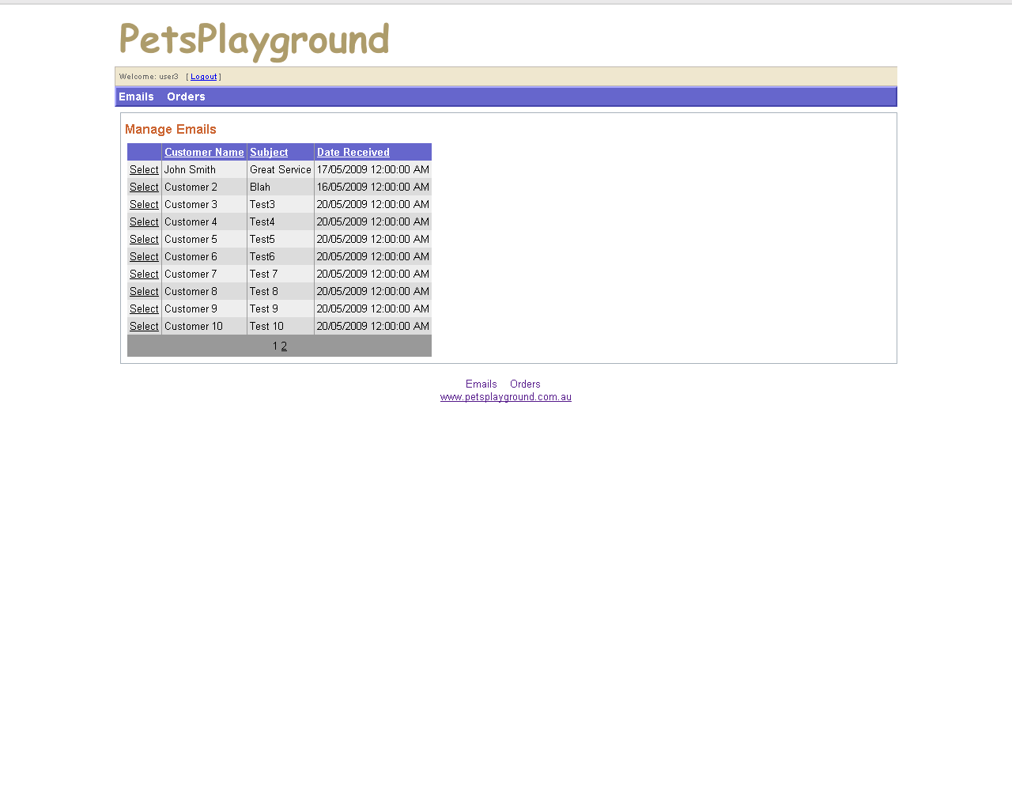
Figure 38 – Staff Home Page

